

Department of Computer Science Course Code: CNS 303
Course Title: Cloud Computing Fundamentals

SPRING 2026

Lab 01

Objective:
Implementation of Web servers in windows / Linux.

Student Information

Student Name
Student ID
Date
Assessment
Marks Obtained
Remarks
Signature

Introduction to web server
A web server can be referred to as either the hardware (the computer) or the software (the computer application) that helps to deliver content that can be accessed through the Internet. The most common use of Web servers is to host Web sites but there are other uses like data storage or for running enterprise applications.

Overview
The primary function of a web server is to deliver web pages on the request to clients. This means delivery of HTML documents and any additional content that may be included by a document, such as images, style sheets and JavaScripts. A client, commonly a web browser or web crawler, initiates communication by making a request for a specific resource using HTTP and the server responds with the content of that resource or an error message if unable to do so. The resource is typically a real file on the server's secondary memory, but this is not necessarily the case and depends on how the web server is implemented. While the primary function is to serve content, a full implementation of HTTP also includes ways of receiving content from clients. This feature is used for submitting web forms, including uploading of files. Many generic web servers also support server-side scripting, e.g., Apache HTTP Server and PHP. This means that the behaviour of the web server can be scripted in separate files, while the actual server software remains unchanged. Usually, this function is used to create HTML documents "on-the-fly" as opposed to returning fixed documents. This is referred to as dynamic and static content respectively. The former is primarily used for retrieving and/or modifying information from databases. The latter is, however, typically much faster and more easily cached. Web servers are not always used for serving the world wide web. They can also be found embedded in devices such as printers, routers, webcams and serving only a local network. The web server may then be used as a part of a system for monitoring and/or administrating the device in question. This usually means that no additional software has to be installed on the client computer, since only a web browser is required (which now is included with most operating systems).
Web Server for Static Content Return content from files, based on the request URL. Very little processing needed. May perform authentication & authorization. May process aliases, perform redirects, URL rewriting. May perform cookie handling & session management. Most Popular Servers: Apache Httpd & Nginx.
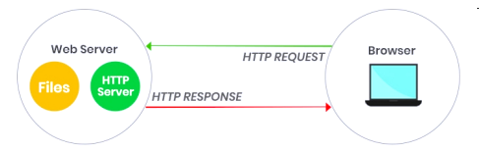

Web Server for Application To create dynamic content, a web application uses "scripts" or applications in a programming language. The web server forwards the HTTP request to the application running in a separate thread or process. The app returns a response (or an i/o stream) that the server returns to the web client. PHP code run in mod_php module Web Client: GET /store/products.php.
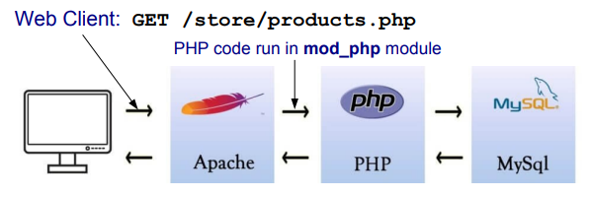

How to Install and configure a web server (Microsoft IIS)

- To start with, click the Windows 11 search icon beside the Windows key in the Taskbar.
- Then, type the word control panel in the Windows 11 search box.
- From the result of your search, double click on Control Panel.
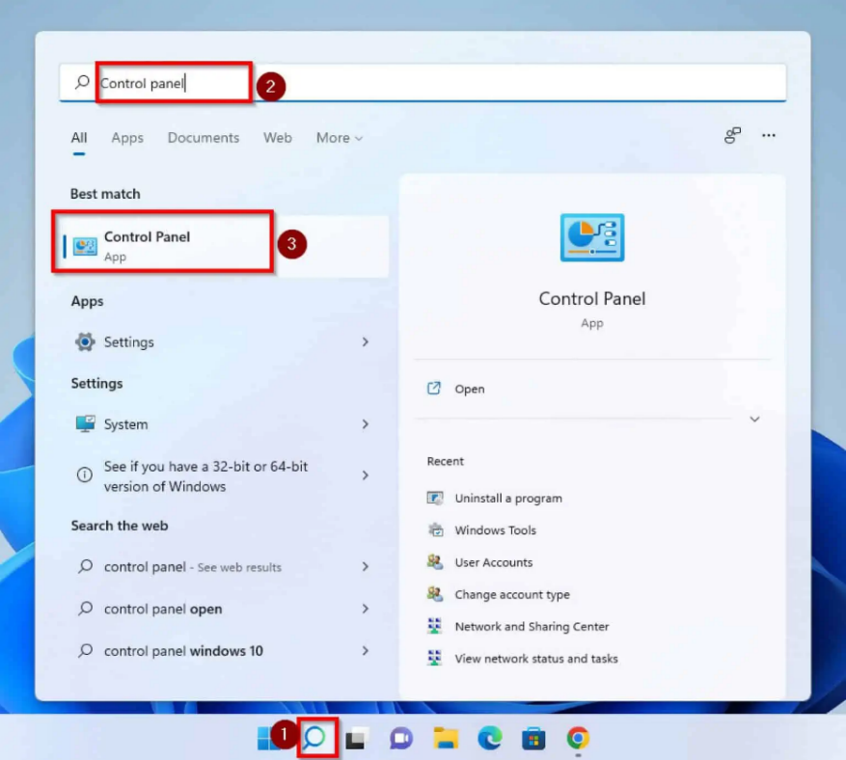

- In Control Panel, confirm that View by is set in the Category option. If it is not on this option, click the drop-down and select Category.
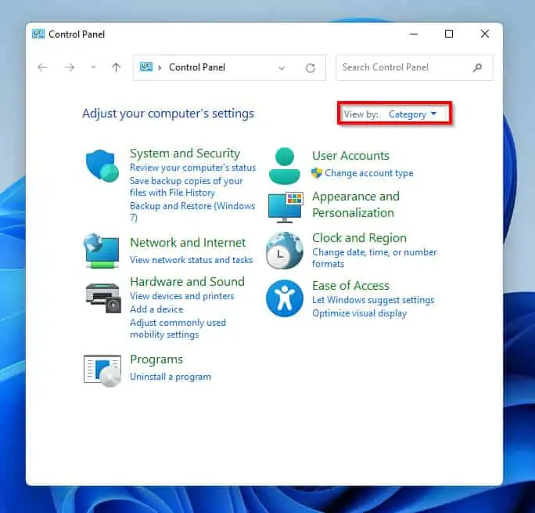
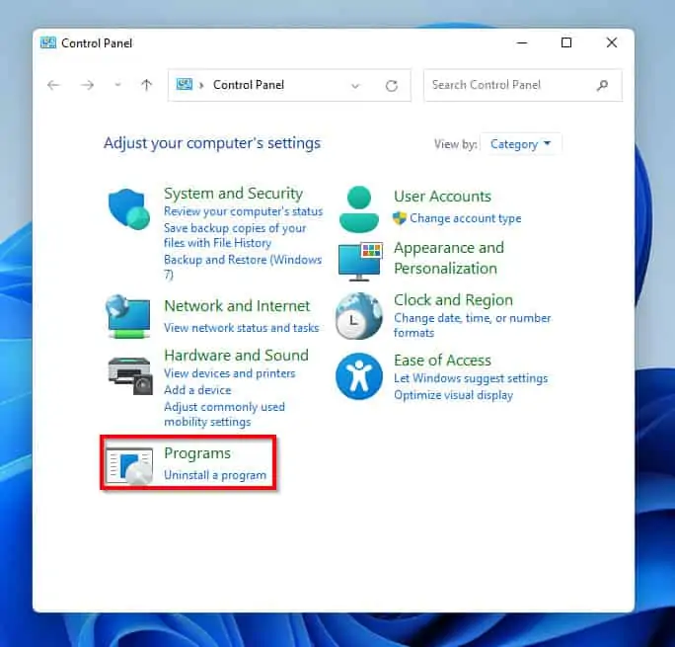
- Once that is done, click on Programs.

- When Programs opens, under the Programs and Features option click on Turn Windows features on or off. Clicking this will open a Windows Features pop-up menu.

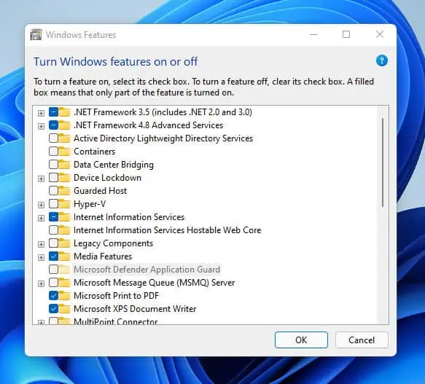
- On the Windows Features pop-up menu, locate the Internet Information Services option and click on the check box beside it. By clicking on the check box you have checked the default sub-features in this option.
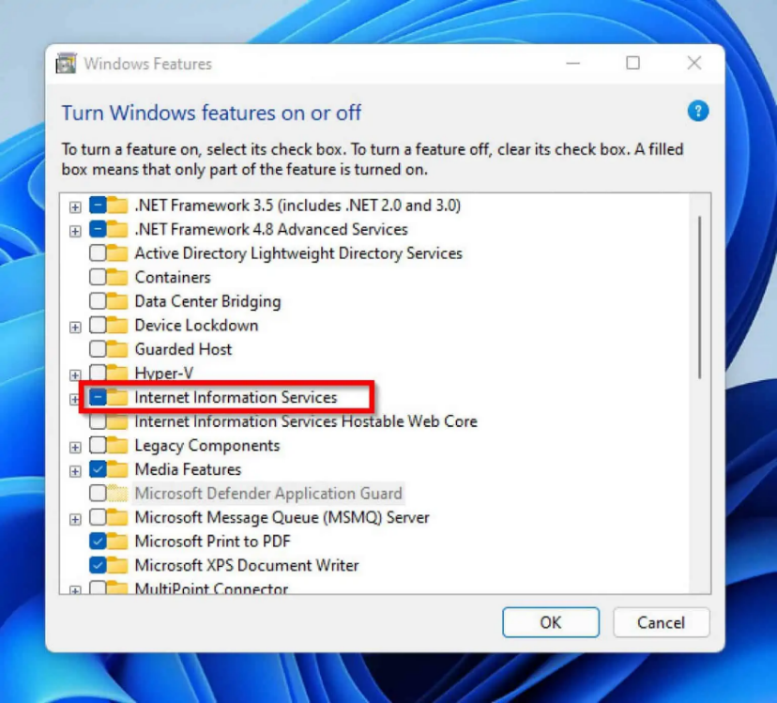

- Still on the Windows Features pop menu, if you wish to customize the features in the Internet Information Services option, click on the + sign beside the check box. Furthermore, you can expand the 3-sub-features folders and check additional feature(s) you wish to add to the installation.
- When you are done with your selection, click on the OK button to start the installation.
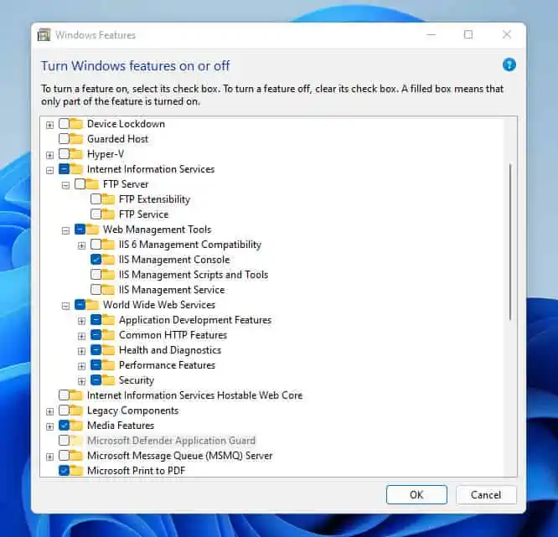

- Then, the installation process will commence by searching for the required files.
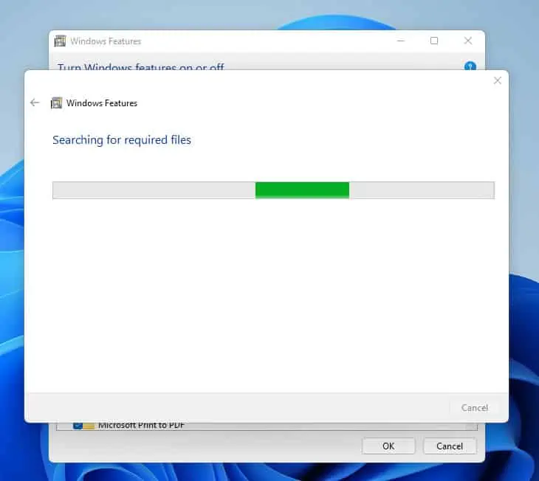
- Once the search is complete, the features will start applying. Here’s what it looks like.
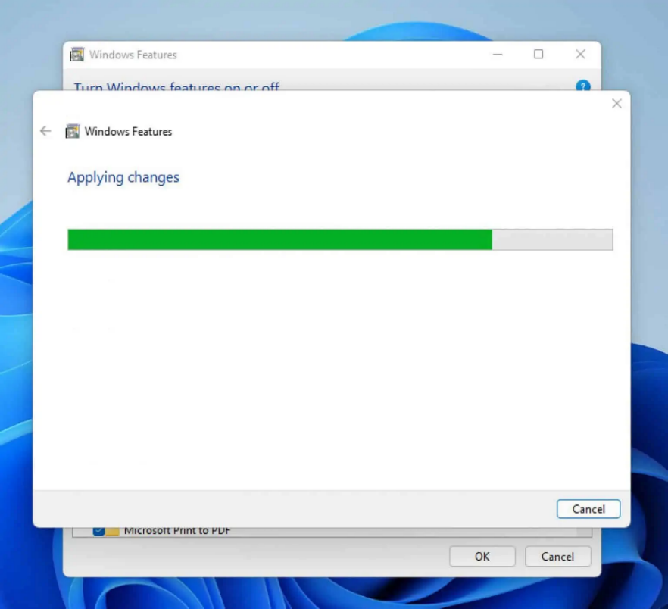

- When the installation is completed, click on the Close button at the bottom right corner of the pop-up screen.
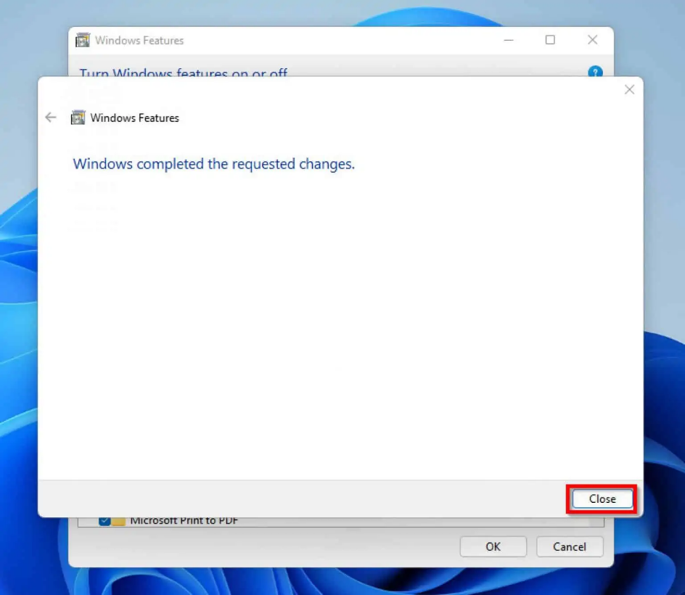
- Furthermore, to confirm that your installation was successful, click on the search icon beside the Windows start and type IIS in the search field.
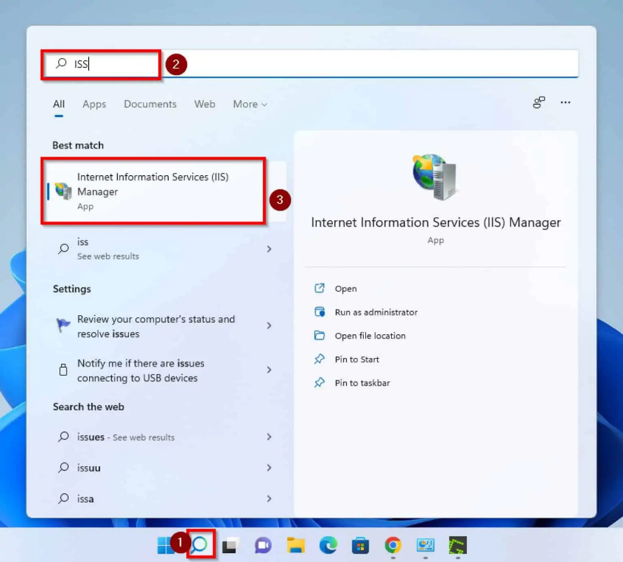
IS (Internet Information Services) is the webserver for Windows systems created by Microsoft. This web server is most popular for hosting .net framework based websites. We can also host other programming languages websites by adding their modules and handlers.
In our previous tutorial, you learned to create a Website, Application Pool, Virtual Directory and Binding via appcmd command-line utility. This article will help you in creating a new website in using IIS manager on a Windows system.

Step 1 – Start IIS
Use the windows navigation menu and open IIS on your system. Or you can directly open IIS by typing inetmgr in run window like below.

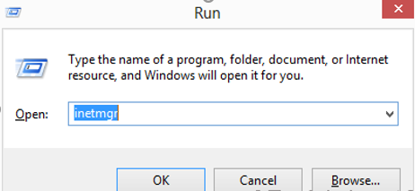

Step 2 – Add new Website
In the left side base expand the tree and select the Sites option. Then Right-click on Sites and select Add Website… option like the following image.

This will open a popup to input new website details. Input the following details in pop-up box.
- Site name: Name of website to be appeared in IIS listing.
- Application pool: Select an application pool or keep is the default to create new application pool same name as sitename.
- Physical path: Enter the location of website pages on system.
- Binding:
  - Type: Select protocol to configure (eg: http or https)
  - IP address: Select ip address from drop list to set dedicated ip for site or keep is the default to use shared ip.
  - Port: Enter port on which site will be accessible for users.
  - Host name: Enter you actual domain name you want to use.
- Start Website immediately: keep this box checked to start site.

Step 3 – Adding Website Alias
If you want to add website aliases like “www.abc.net”. Open IIS, select your site and click on Bindings. You will get Site binding screen like below
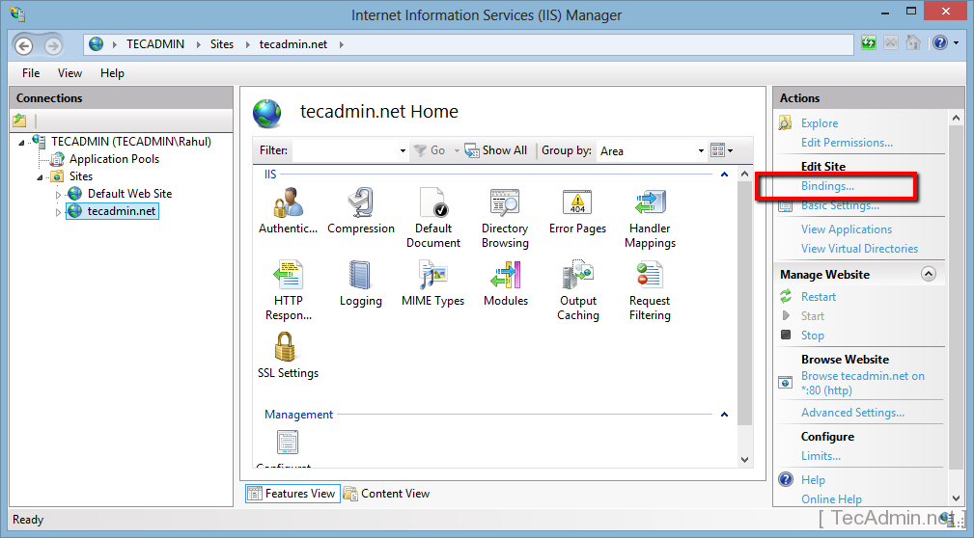
Click on Add button it will open site binding box.
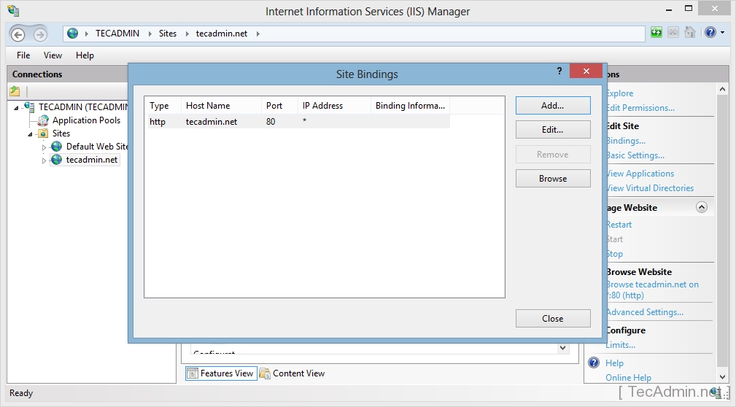
Enter the hostname of your site aliases like www.tecadmin.net, demo.tecadmin.net or stage.tecadmin.net and input other details and click Ok.
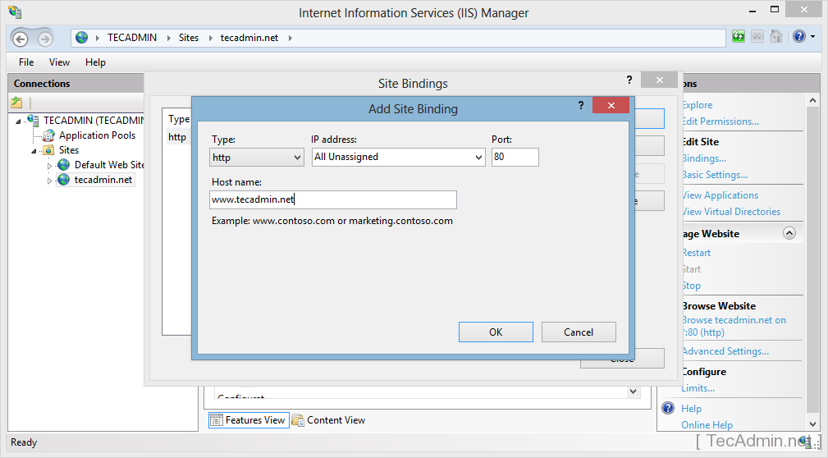

Step 4 – Verify Configuration
To verify configuration you can simply access the site in a web browser. If your domain is not pointed to this server do host file entry and check.

LAB TASK:
- Create the IIS environment over windows.
- Configure the IIS server for two websites.
- Create apache environment over linux [This server is deployed over the Virtual machine (Linux)].
- Configure the apache server for a single website.
- Access all the websites from the host or network connected machines as we are not using the public IP.
- Install the MS Sql server.
  - Create a small data base.
  - Access the data base from the back end code.
    - Hosted on either IIS or Apache.
- Show the reflection of data on web browser through web server.

